

Encarnacao Alliance MATUL Commission
Manila Meetings, June 23-27th, 2008

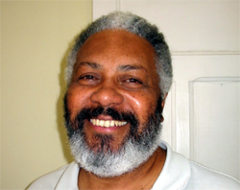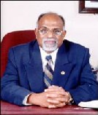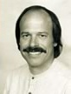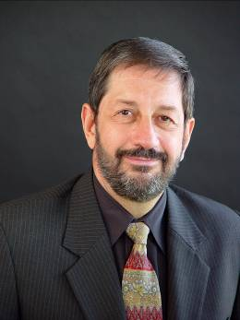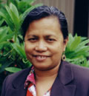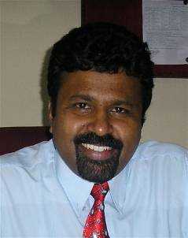



Training Catalysts within the
50,000 from the Slums to the Slums


Encarnacao Alliance MATUL Commission
Manila Meetings, June 23-27th, 2008

Index
- Proposed Outcomes
- Personnel
- Program

- Introduction
Vision: Jesus’ Seminary in the Slums
History: Radical Discontinuity
Present:
Future:

- Program Design Issues
Common Master Program
ATS Report
HBI Report
APU Report
Nairobi Report
AULI Proposal
FLAM Proposal
Variances
Faculty

- Course Design
Master Course Outlines
Outlines from Schools
Evaluation Criteria

- International Relationships
  - What is the Alliance?
  - What is the MATUL Commission?
    - Progression from Catalyst Group to Professional Commission
    - Next Steps
    - Operational Capacity
    - Job Descriptions
  - Case Studies of potential trainees
  - MOU’s Between Schools
  - MOU with the Alliance

/tmp/in/input.doc

Educational Entrepreneurs
Encarnacao Alliance MATUL Commission
2008 Gathering of Program Leaders
June 23-26th, ATS, Manila

Proposed Outcomes:
- Enjoy and love each other , supporting each other in the complex tasks of leadership of schools
- To complete the launch phase of the MATUL in three schools, and initiate in two new schools .
- To contrast with the African BA model and evaluate future African MA connections and Latin partnership options
- To peer review the course outlines, descriptions and outcomes from each school and make suggestions how they can be developed in such a way that the outcomes of the program are obtained.
- Peer review total programs processes and evaluate outcomes thus far
  - Explain intended variances
  - Determine core text booklist
- To define the MATUL Commission objectives for the next 2-3 years,
- identify the nature of the Commission for the next phase
- Define roles and partnership in budget
- To finalise MOU'S between schools and between schools and the common program proposal of the commission.

Dates and Schedule: arrive night 22nd, work 23-25th evening, day of consultations, 26th depart morning 27th.

Personnel:
- Dr Corrie de Boer, chairperson MATUL Commission:
- Dr Viv Grigg, Coordinator MATUL Commision, and Project Director, Auckland Urban Leadership Institute
- Dr Paul Cornelius, Principal, Hindustan Bible Institute
- Dr PN Saravanan, Hindustan Bible Institute
- Dr Rich Slimbach, program designer, Asuza Pacific University
- Dr Lee Wanak, Asian Theological Seminary
- ____________, adjunct faculty, ATS
- ____________, adjunct faculty, ATS
- Colin Smith , Director, Carlisle College, Nairobi
- (Apologies: Ivone, Arivaldo Ramos , Director and Principal, Faculdade Latino Americana de Theologia Integral, Sao Paulo www.faculdadelatinoamericana.com.br. Video at http://video.aol.com/video-detail/flam-faculdade-latino-americana-de-teologia-integral/3633407479 )
- Chze Pheng, Auckland Urban Leadership Institute Committee.

10 people
+ visitors from ATS

Proposed Program

For those who arrive early.
22nd visit evening church services in slum or city ???

23rd 9 a.m-1 pm
- Worship (15 mins)
- Welcome by President of ATS ? (15 mins)
- Introduction of Participants - (15 mins)
Envisioning
- Review of the mandate, the core values and vision of seeding 50,000, and progress accomplished thus far - Viv (30 mins)
- Presentation by each school of video as to what is happening
  - India (20 mins)
  - Manila (20 mins)
  - APU (15 mins)
  - Auckland (15 mins)
  - Sao Paulo (15 mins)
  - Nairobi (30 mins) (Colin to do this when he arrives)
- Identification of issues for discussion (15 mins)
- Summary of issues for discussion - Corrie (10 mins)
- Review time/ plan for discussions - Corrie (10 mins)
  - Define limits of discussions so we don't get sidetracked (eg we do not wish to spend hours debating whether we are an accreditation commission or on details of MOU's)
- Worship
23rd 2-6 pm and 24th 9 am-1 pm
Program Design
- Worship (15 mins)
- Intercession (15 mins)
- Colin introduced. Present Nairobi model (30 mins)
- Review/ accept/delete the suggested changes to the core Program Proposal (1 hour)

- Review course descriptions of each of 16 courses (30 mins)
  - Main contention is Field Ed .
- Review course outlines in groups of 3 based on existing evaluations (3 hours)
- Review the thorny issue of praxis base for each course (30 mins)
- Evaluate whether current courses are producing the program outcomes of churchplanters, holistic workers etc. (30 mins)
- Review the core texts and confirm core texts (30 mins)
- Review Variances (30 mins)
  - Lack of adequate churchplanting course
  - Additional theological courses
  - Individual schools
- Worship
Evening of 23rd go out for dinner in slum? Luneta?
Colin arrives 1635 pm

24th 2-6pm
Envisioning the Network
- What are the objectives of the commission from here on out
  - Presentation by Viv/Corrie (20 mins)
  - The African Network - Colin (30 mins)
  - The Latin Needs - Viv (10 mins)
  - The Global Download option - Rich (20 mins)
  - The South Pacific Base - Viv (10 mins)
  - Discussion and Redefining Objectives - Viv/Corrie (30 mins)
- Details of the Commission (contentious issues) (1 hour) Viv or Corrie
  - What is essential? Can we have a TUL at BA and at MA levels partnering. When does a program cease to be part of the MATUL ?
  - Definition of the commission as an entrepreneurial think-tank of a movement Differentiation from Institutional Accrediting bodies
  - Decide on future meetings - Corrie to present options
  - Review budget to run commission - Viv to present options
  - Roles within the commission for the next year Viv/Corrie
  - Exchanges of professors
  - Future publishing processes
  - Dates for next meetings
  - SKYPE Call dates and processes
- Worship
- Evening groups on ad hoc basis to finalise documentation of course evaluations
- Return booklist analyses to Chze Pheng by next morning
25th am
Worship (15 mins)
Intercession (15 mins)
Continue with review of courses and MATUL Commission

11pm Engaging with ATS Constituency Chapel

25th am and pm
Finalising MOU's
- Finalise MOU's with the Encarnacao Alliance - based on the existing program proposal - refined Viv/Cory . (1 hour)
- Finalise MOU's between schools - Rich (3 hours)
- Finalise course outline discussions, program proposal discussions (2 hours)
- Finalise other decisions from previous days (1 hours)
25th evening
- Reflections on process of the last couple of days from Colin and Chze Pheng and implications for them
- Reflections on input from others and implications for HBI and ATS
- Final Vision presentation - Viv et al (Could be presentation to public)
- Worship

Style: coffee bar style or do we have some sessions in more relaxing places. What can you suggest. Kind of boring sitting in a room for long hours.

Thursday 26th
8:30 – 1:00 p.m. Movement Leaders Discussion with Viv evaluating the three course designs from the three schools. MATUL Commission invited to sit in.

Outcome in the morning

1. Review processes of discerning program outcomes
2. What differentiates a movement leader from a church planter or pastor? How is this different for a slum movement leader?
3. What were he critical breaks for them
4. How do you move people through paradigms that enable this.
5. Review the three course designs from Auckland, from Bobby Gupta, from Joetique (he has done one?). DO these accomplish the goals discussed? Do they contain the critical paradigm shifts?

Afternoon 2-4pm

Time of feedback from ATS stakeholders so they can influence global processes.

1. Review by Viv of history, processes of development and partners in the development of the MATUL globally.

2. At the outset we set out to facilitate the emergence of a Filipino program for training slum movement leaders and holistic ministry leaders. We worked hard across 20 cities round the world to find out what was needed, then used Rich expertise to reduce this to 16 courses, Larry then integrated this into ATS structure, Corrie recruited practitioner-faculty and Lee was given the hard task of making it work.

3. Discussion of genuineness and unity in the indigenous process.

4. Discussion on contribution of Filipinos to global process.

